**Assignment WEEK-2 Report**

**Objective**

* Build campus graph.
* Implement pathfinding algorithms.
* Prepare backend for integration.

**Tasks Completed**

* Created node and edge list with distances.
* Represented campus as weighted undirected graph.
* Implemented BFS, DFS, UCS, A*.
* Validated algorithms with sample queries.

**System Architecture**

User → NLP → Python Navigator → Graph Data → Result

**Graph map of Campus**

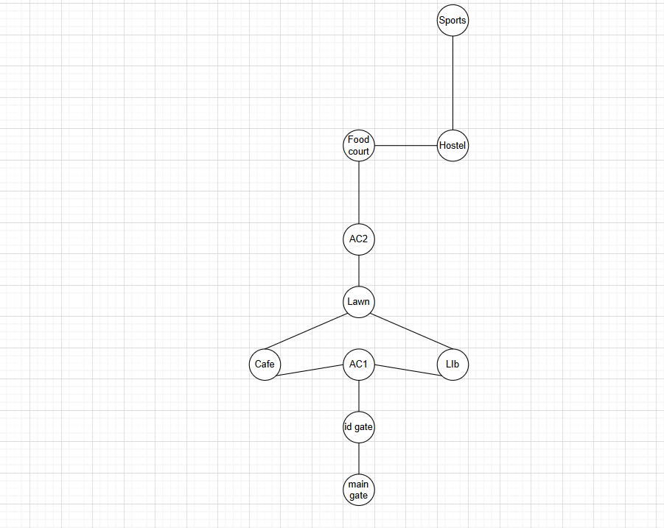

**Code**

* Graph to be implemented in Code using NODE concept.
* Using Algorithms like BFS, DFS, A* to find the path from place to place.
* Python Code to be written and chat bot to be made later.